Computing Vision
Lab 4
Huzaifa Amir
23108113
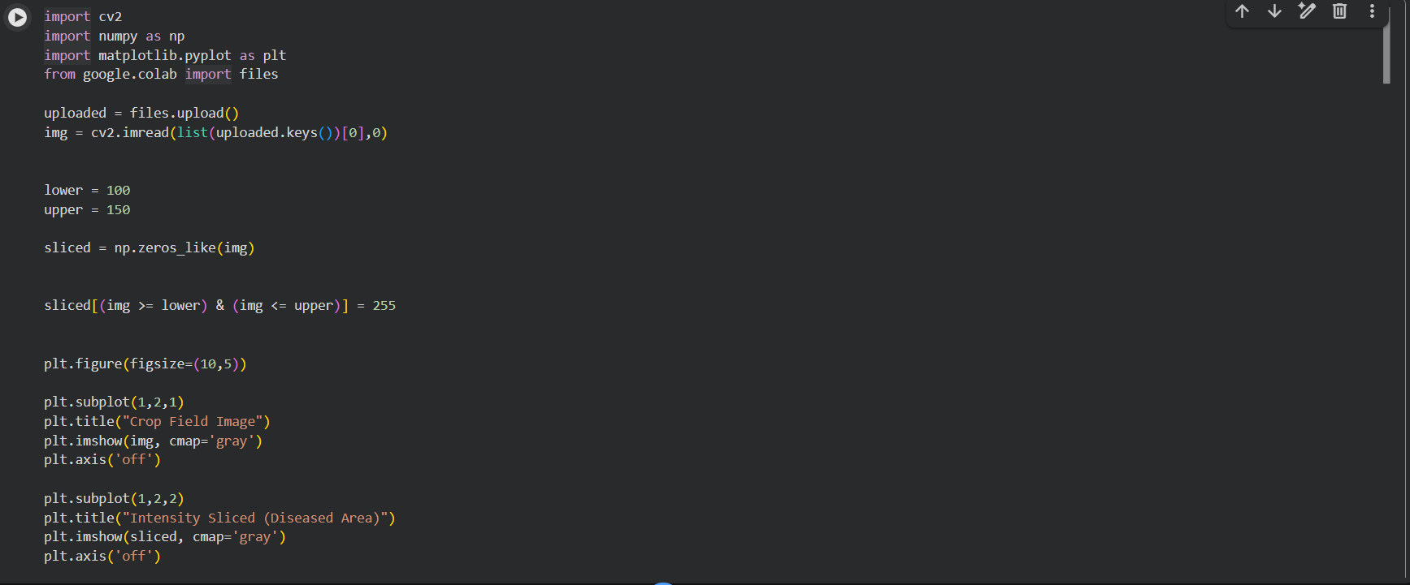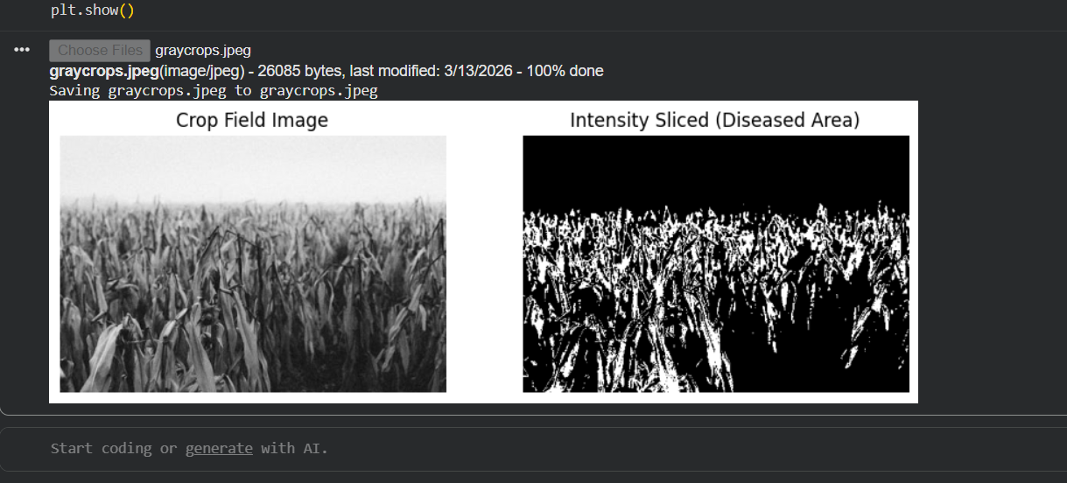

Github:

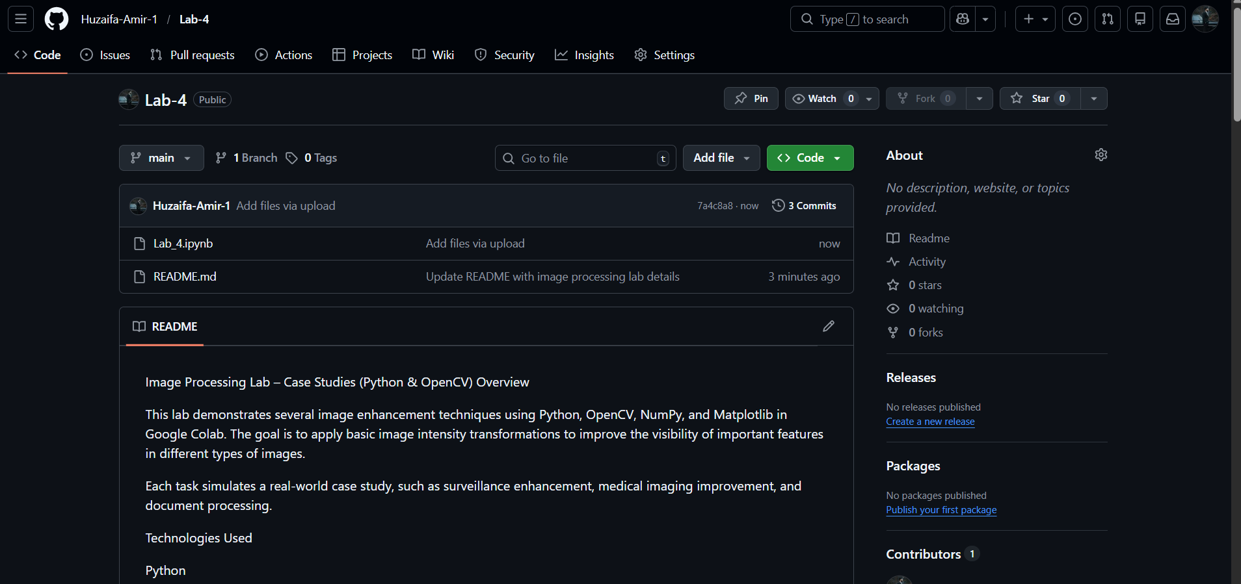
https://github.com/Huzaifa-Amir-1/Lab-4

